**Data Transform Rule:**

* **Data Model-> Data Transform**
* **It is an instance of  Rule-Obj-Model**
* **Before 6.2 Data transform is called as Model Rule.**
* **From 6.2 Data Transform is introduced.**
* **Data Transform contains Functions ( Basic & Advanced Functions)**

**The Data Transform Rule is used to Perform Property set Operation:**

**Using Data Transform we can**

1. **Set/Assign Default values to Properties (pyDefault)**
2. **We can assign value from Property-Property, Page-Page and Page List - Page List.**

**Data Transform can be called from**

* **In Data Transform Rule Using Apply Data Transform Function.**
* **In Activity Rule Using Apply-Data Transform Method.**

**Working with Data Transform:**

**Create a New section to capture Billing & Shipping Address.**

**- When user selects the checkbox, copy shipping address with existing billing address and display shipping address details in read only**

**- If check box not selected user should be able to enter new shipping address**

**Create a Data Class from Data Type Explorer:**

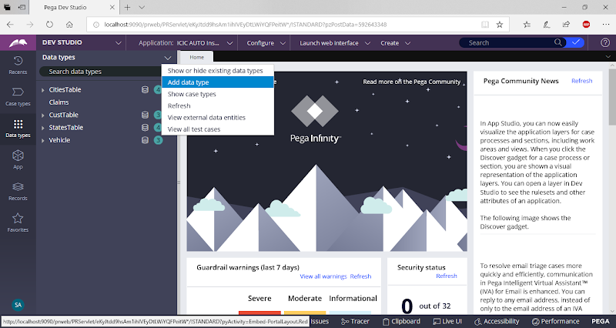

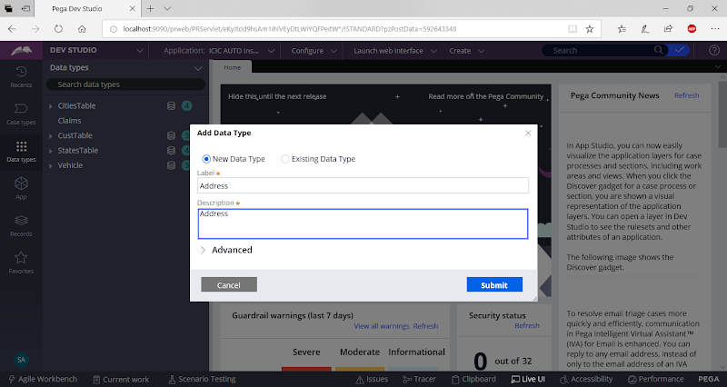

**Click on Submit**

**Add Properties**

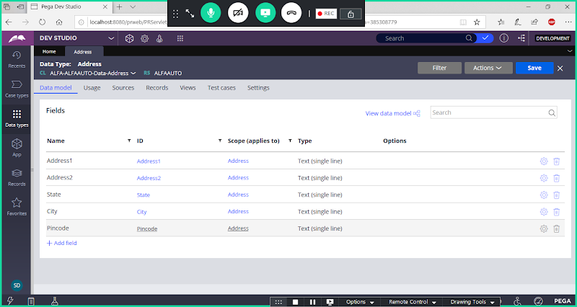

**Now Open Work Layer.**

**Add Page Properties referring to Address Class:**

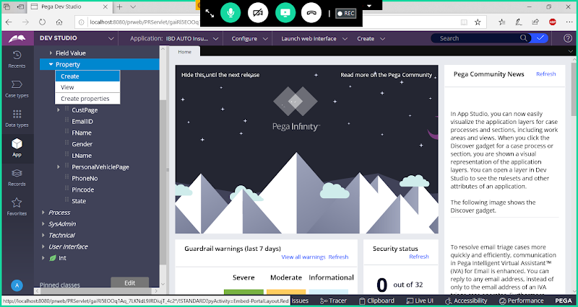

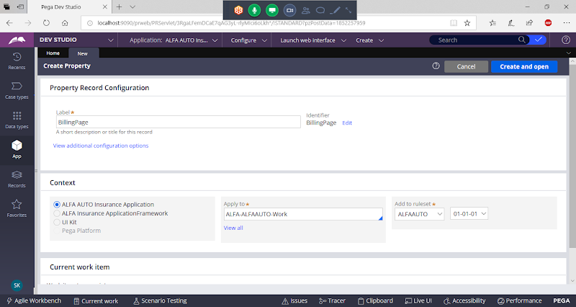

**Open**

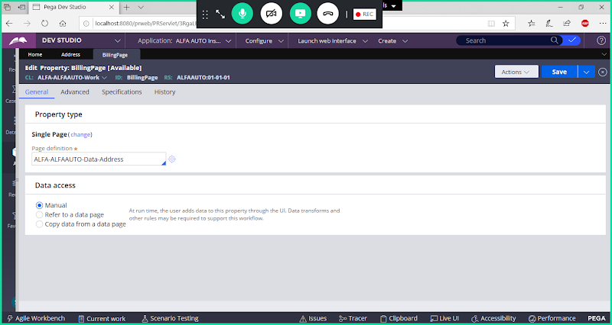

**Save**

**Add another Page Property:**

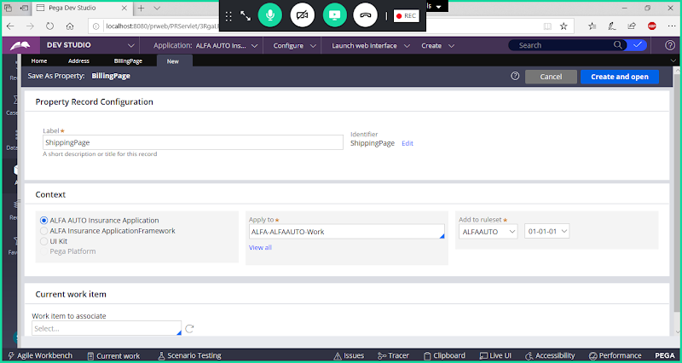

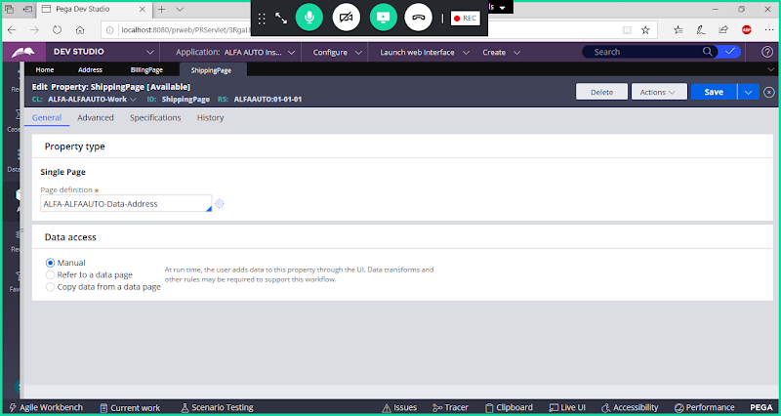

**Save**

**Create Sections:**

**Section1: Add Billing_Section:**

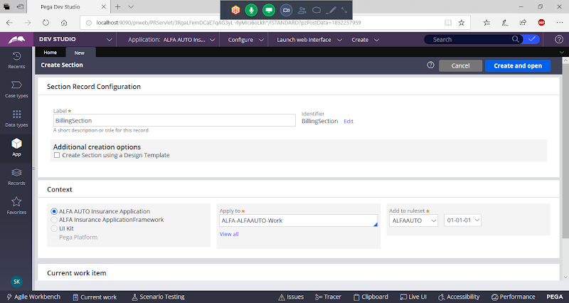

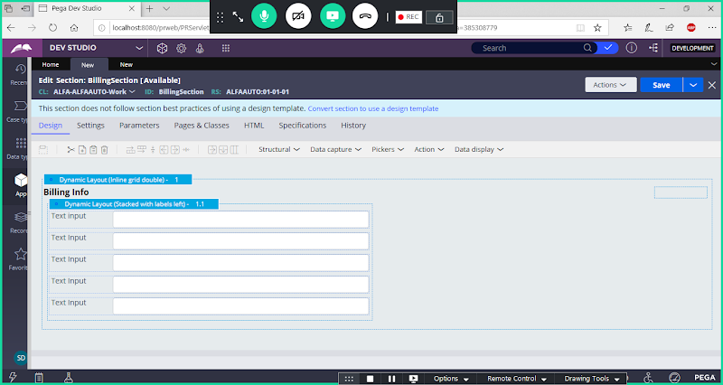

**Add Properties**

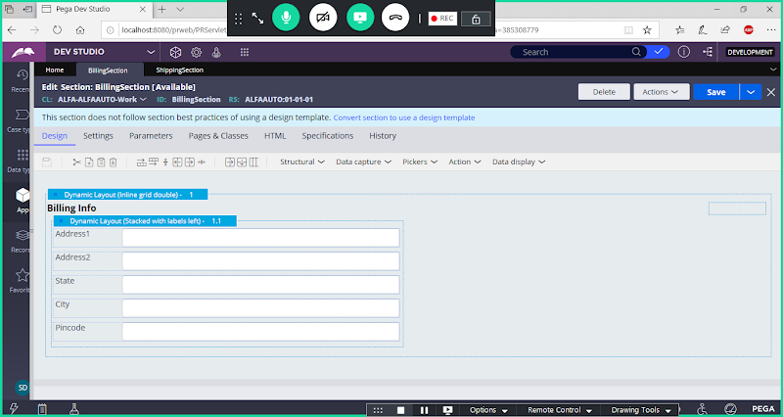

**Save Section**

**Section2: Add Shipping Section:**

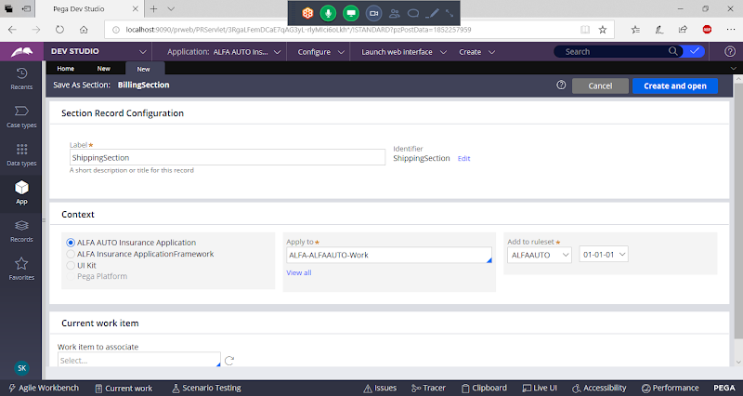

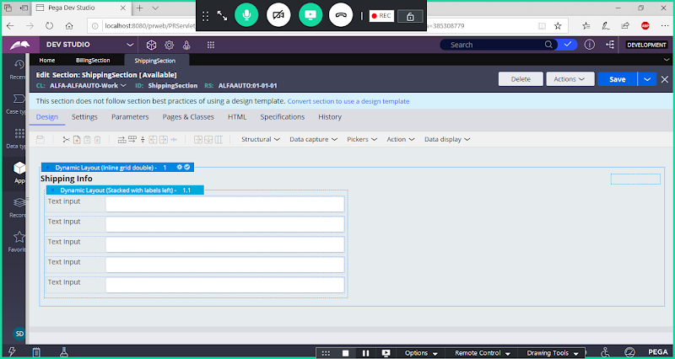

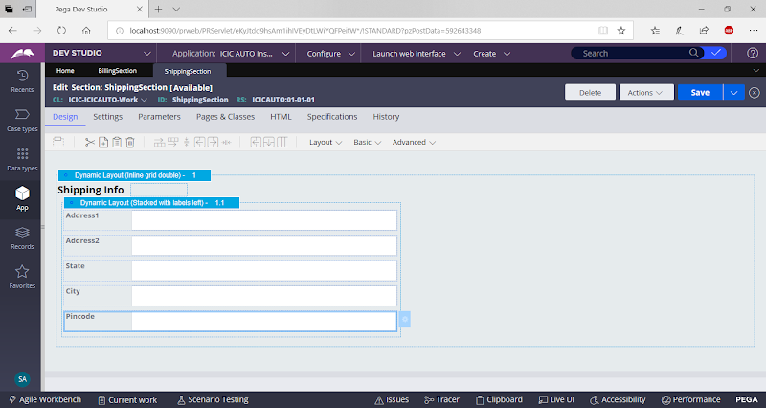

**save section**

**Add Check box Property:**

**Open Property Wizard**

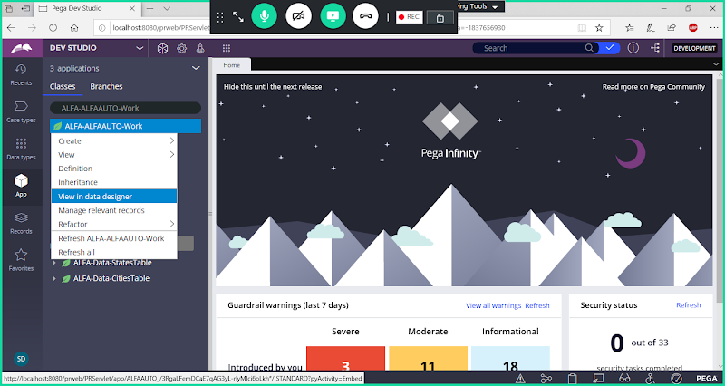

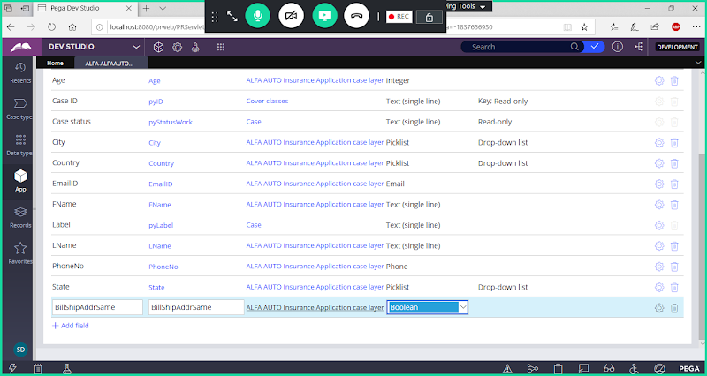

**Type : Boolean**

**Create Address Section:**

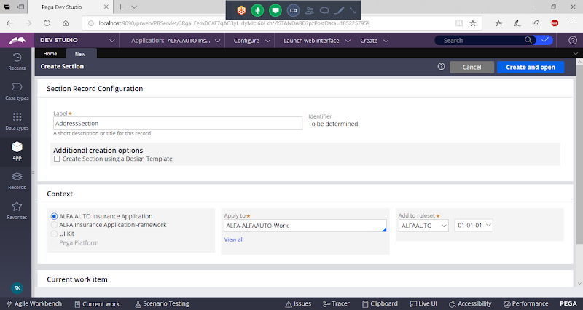

**Drag & Drop Sections & Check box**

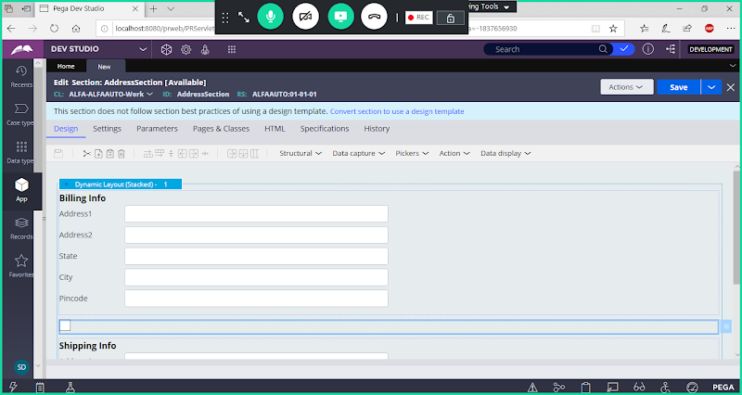

**Add Caption for Check box Property**

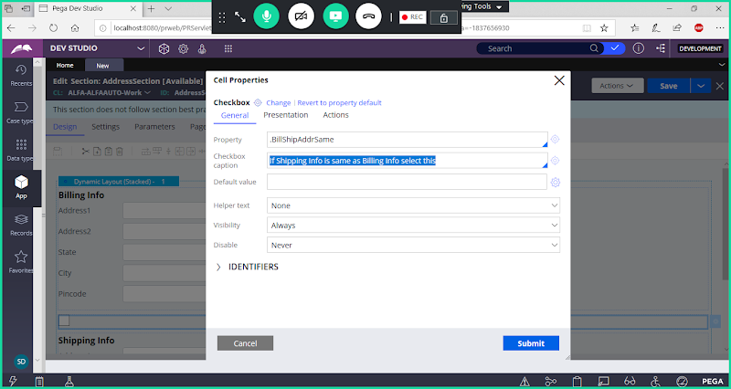

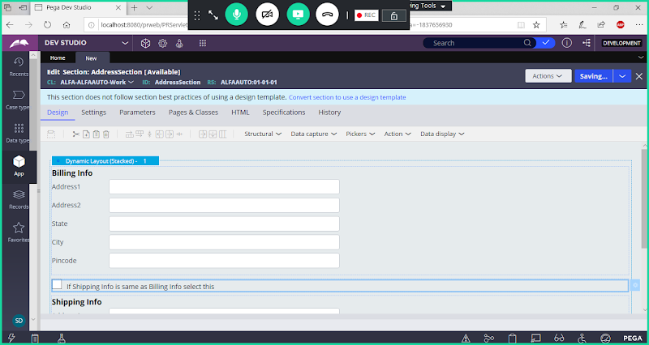

**Save Section**

**Add Flowaction:**

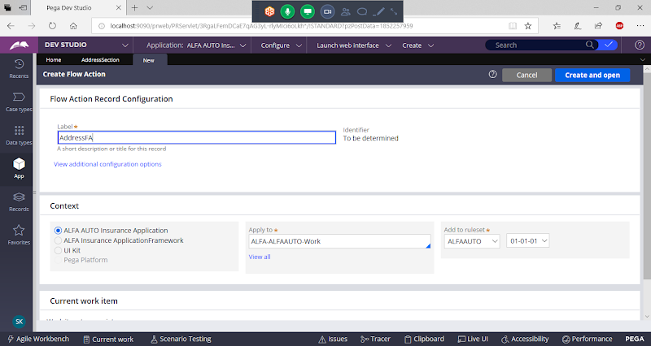

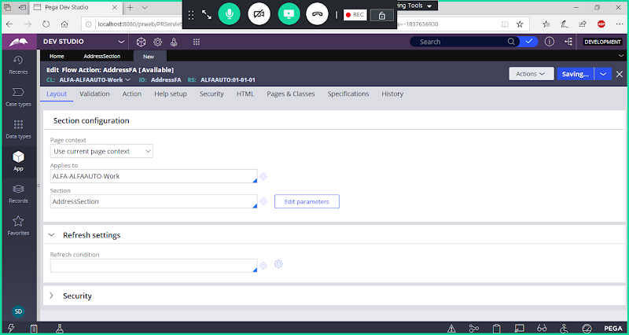

**Save**

**Create a When Condition:**

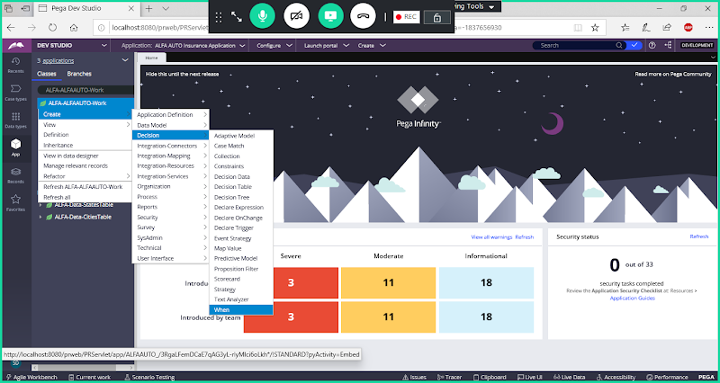

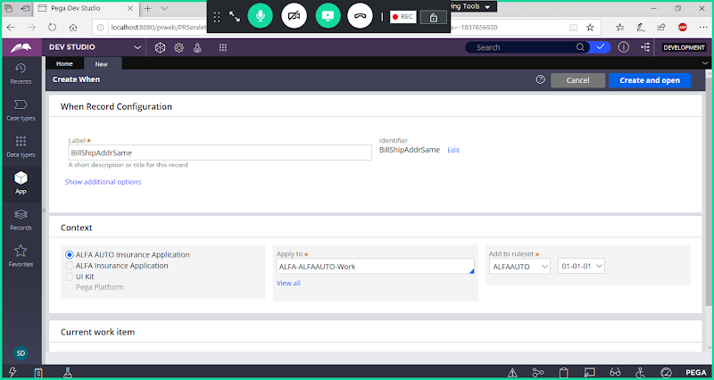

**Open**

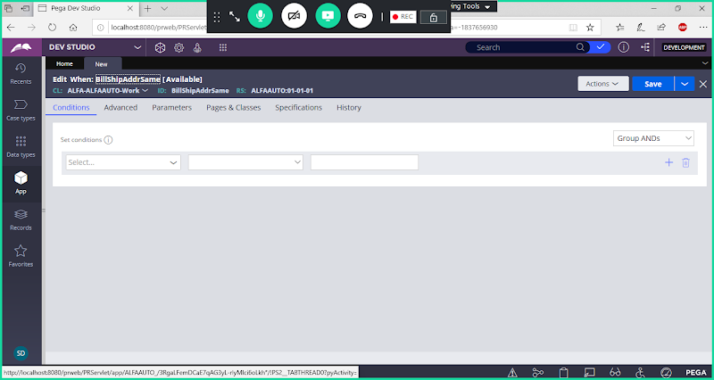

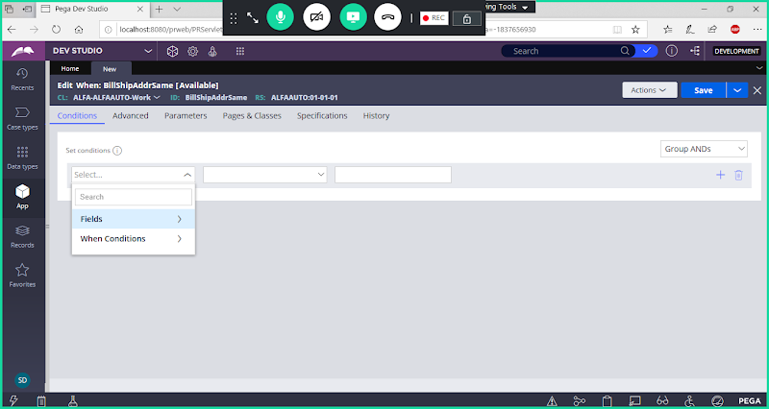

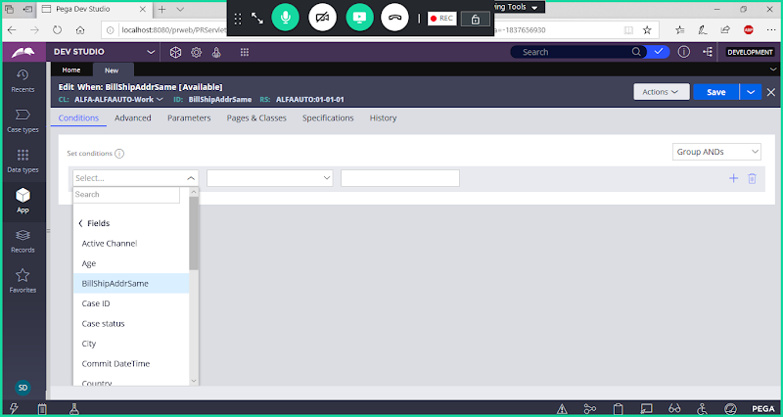

**Select Property**

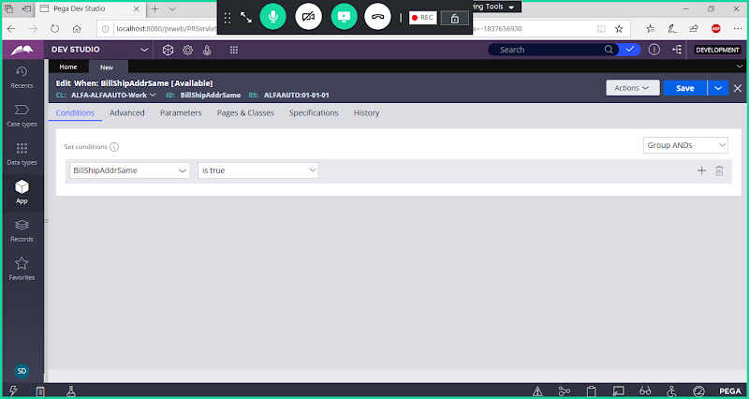

**Save When**

**Add Data Transform Rule:**

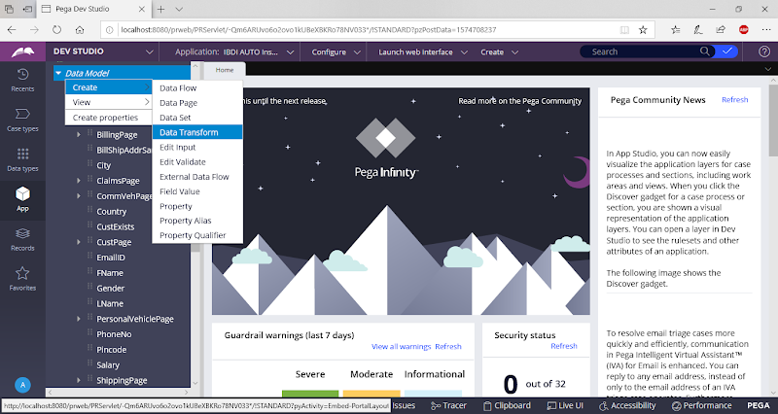

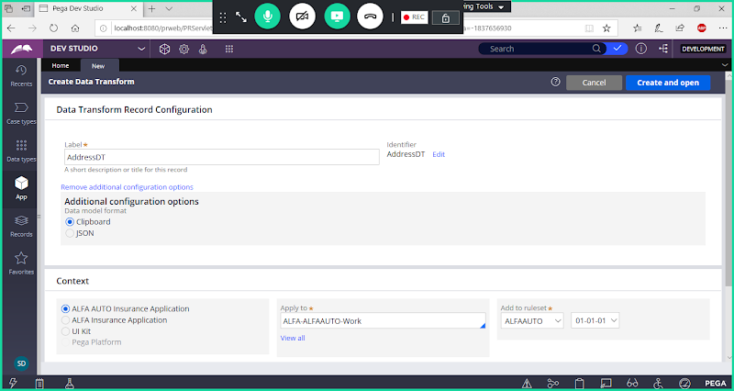

**open**

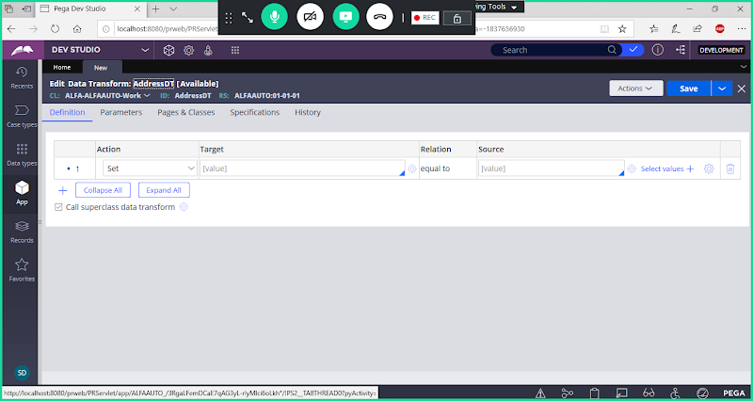

**In Step 1 - Select When**

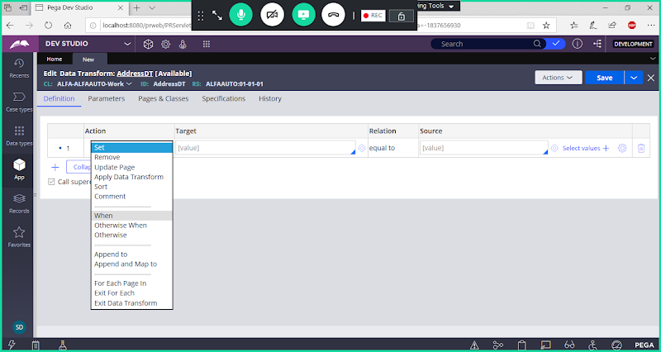

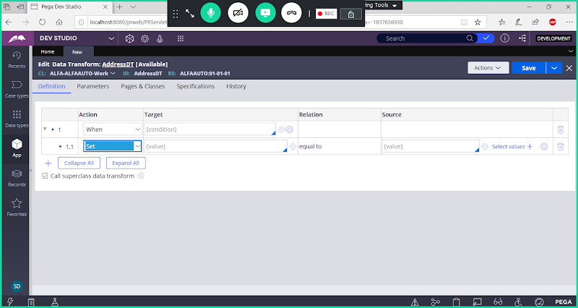

**Call ur When Condition**

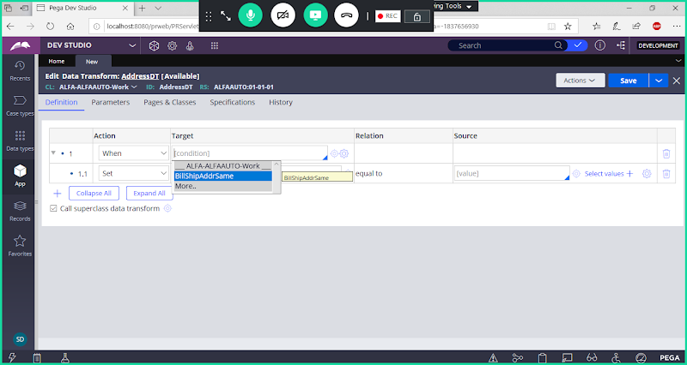

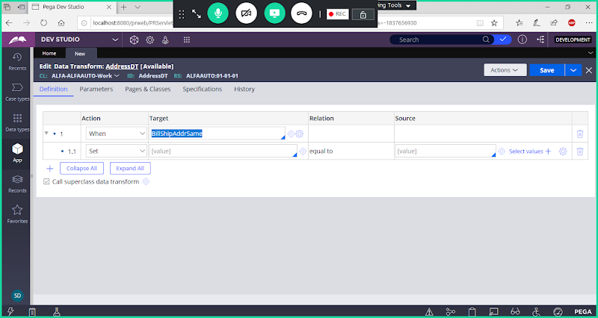

**Select Update Page  Function under Step ( 1.1)**

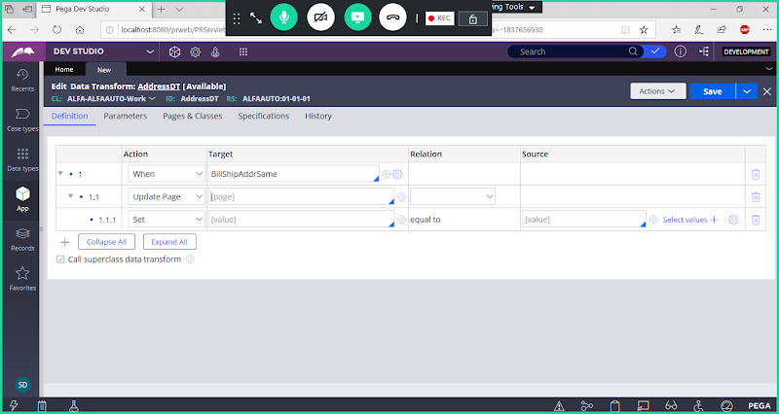

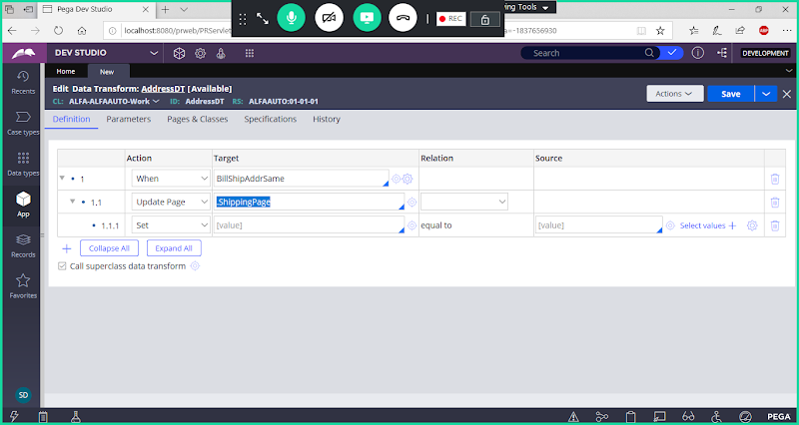

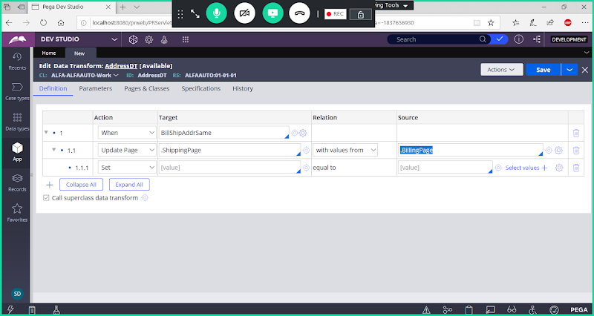

**Now Set Values for Properties**

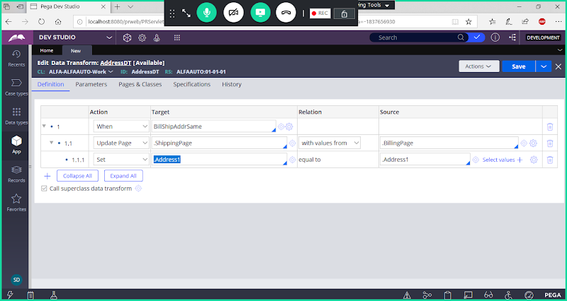

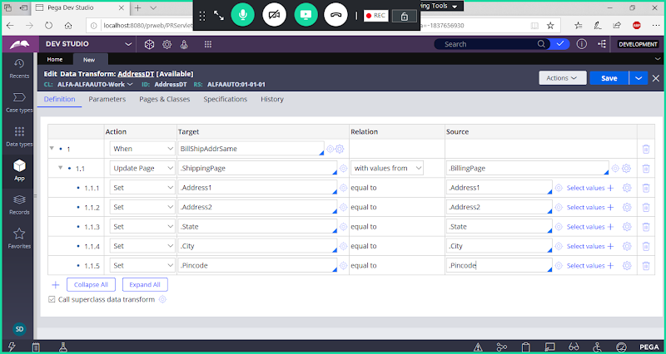

**Collapse all steps:**

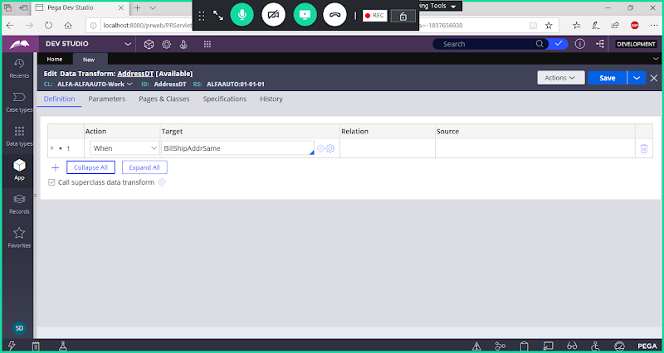

**Add New Step ( Step 2)**

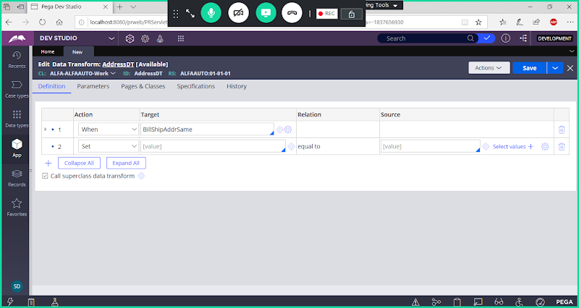

**In step 2 select Otherwise:**

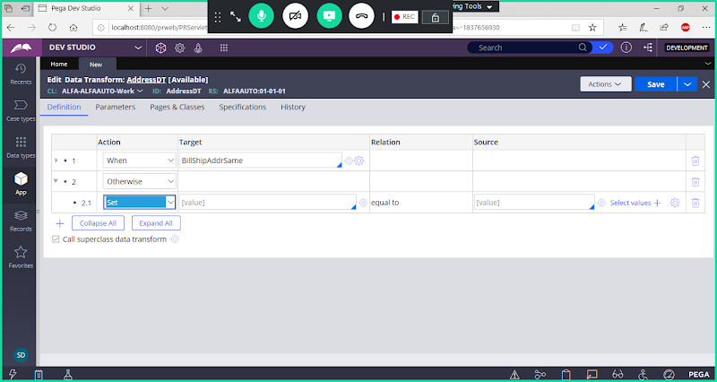

**In 2.1 Select Update Page**

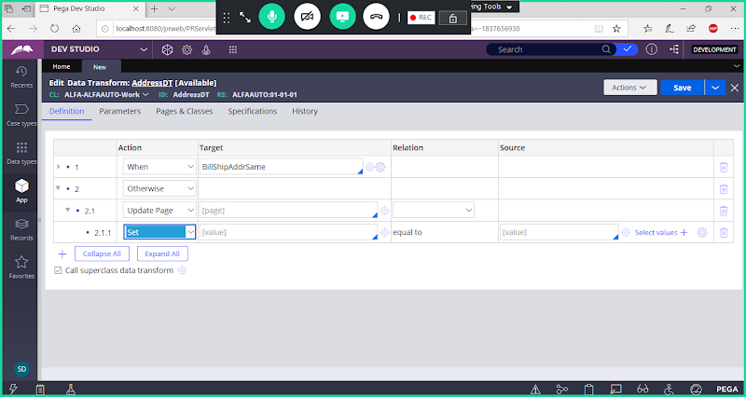

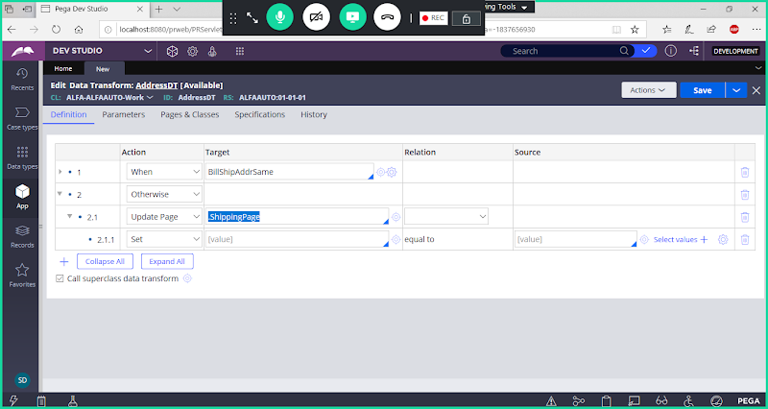

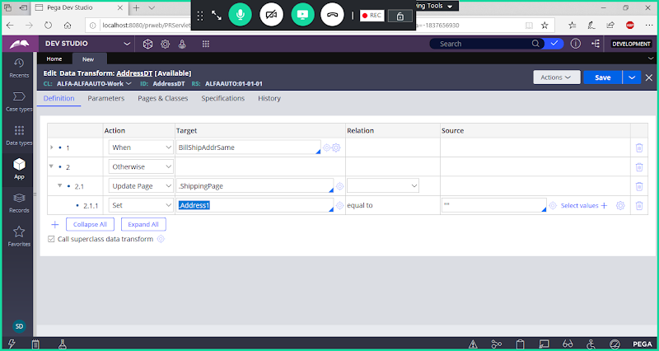

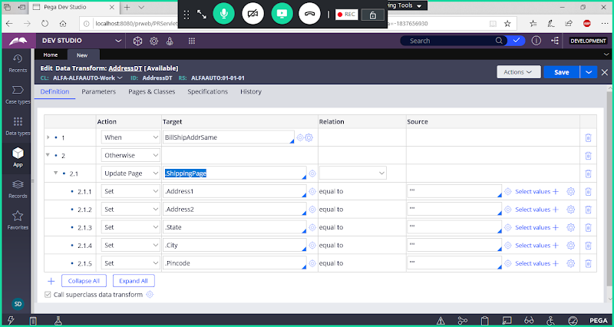

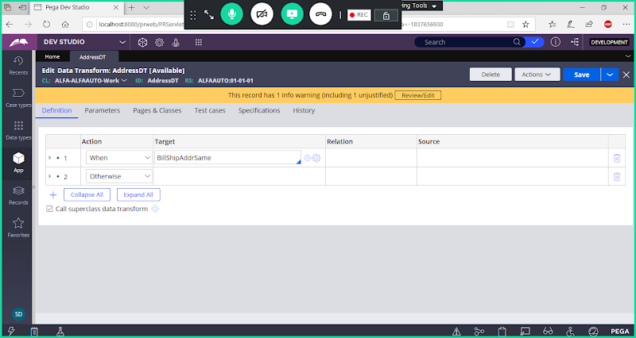

**Save Data Transform:**

**Now Call this Data Transform Under Check box settings**

**Open Address Section**

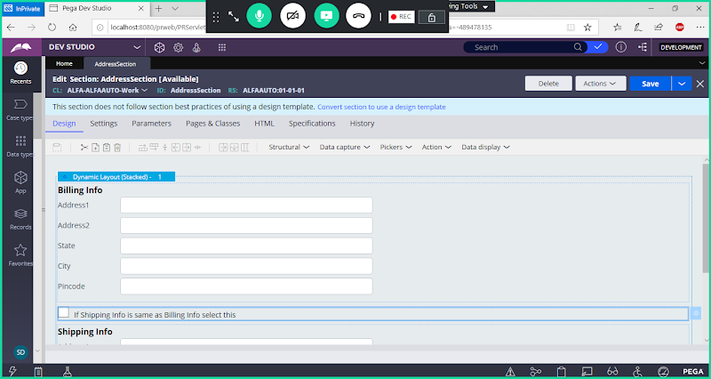

**Double Click on Check Box**

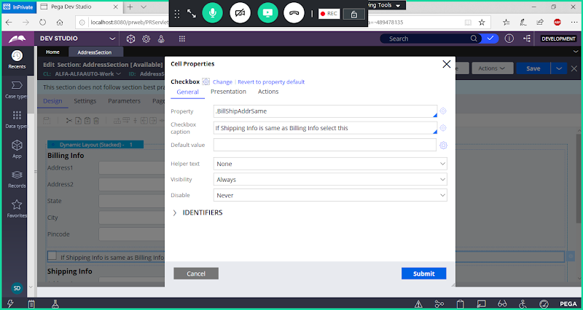

**Actions-> Create an Action Set -> Add Event & Action**

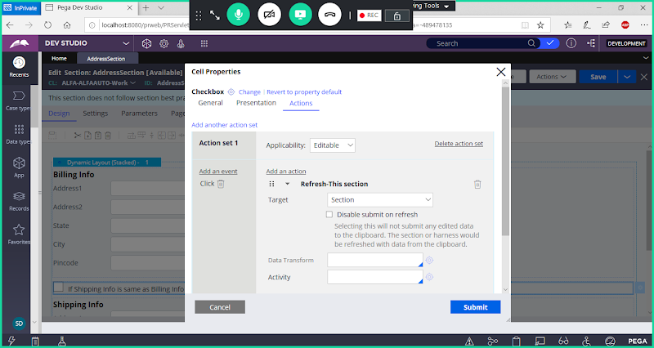

**Now Add Data Transform Name**

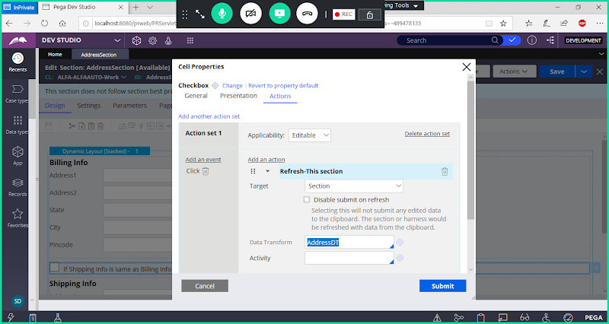

**Submit**

**Open Shipping Address Layout Settings & Set all Fields as Read Only:**

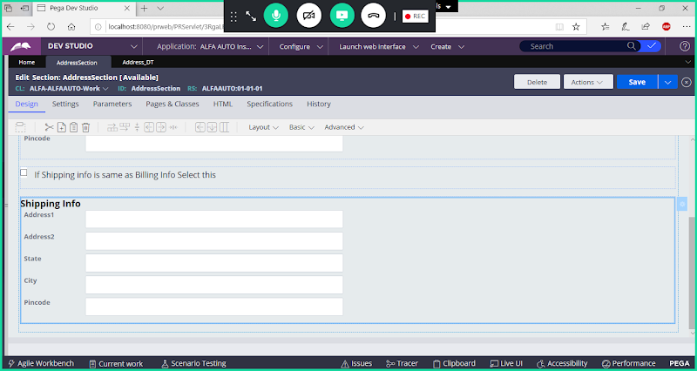

**Double Click on Shipping Address Layout**

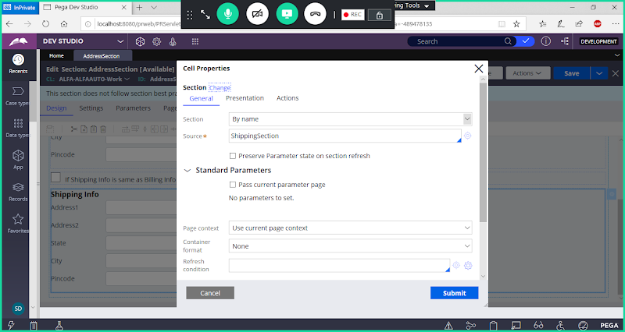

**Go to Presentation Tab:**

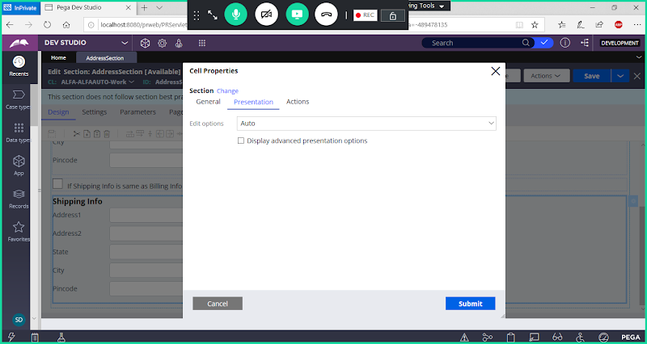

**Select Read Only When & Call When Condition**

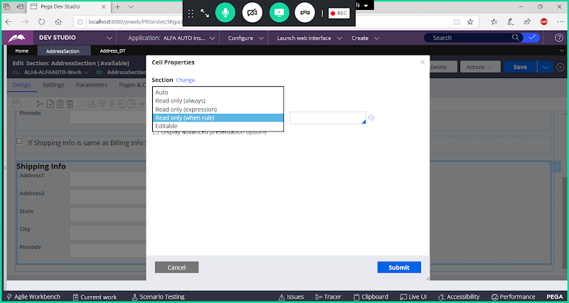

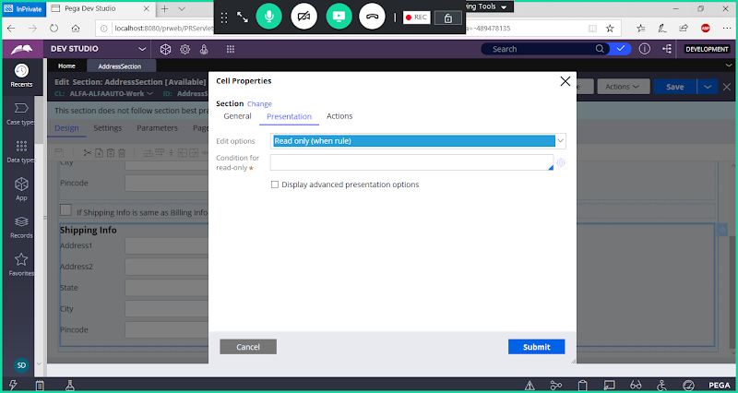

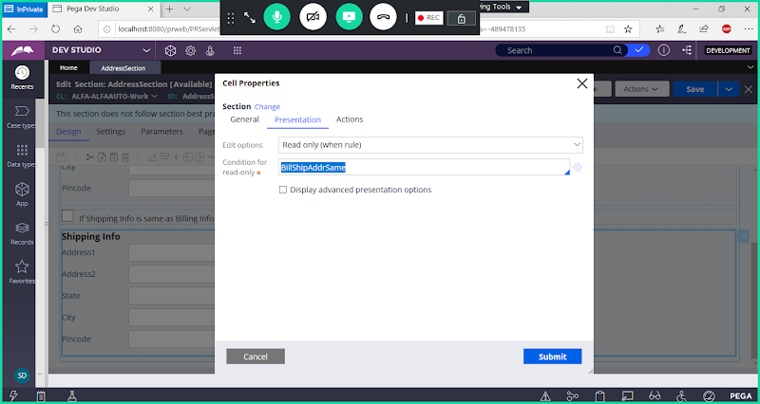

**Submit**

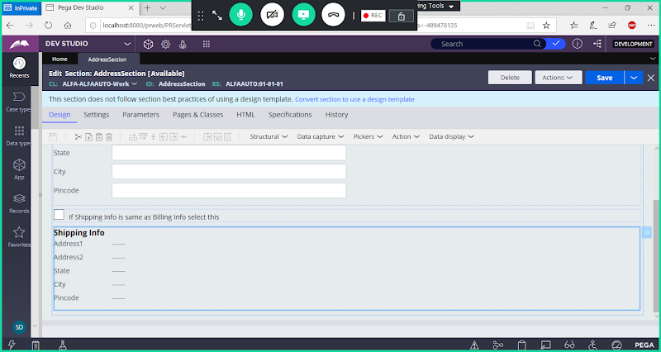

**Save Address Section**

**Call Address Flowaction in Insurance Flow:**

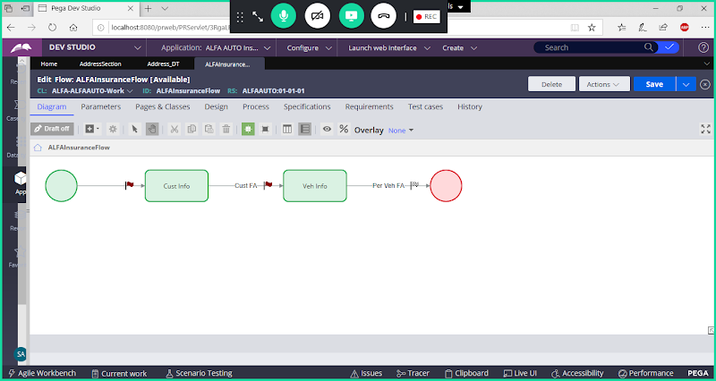

**Add New Assignment after Personal Vehicle details Assignment**

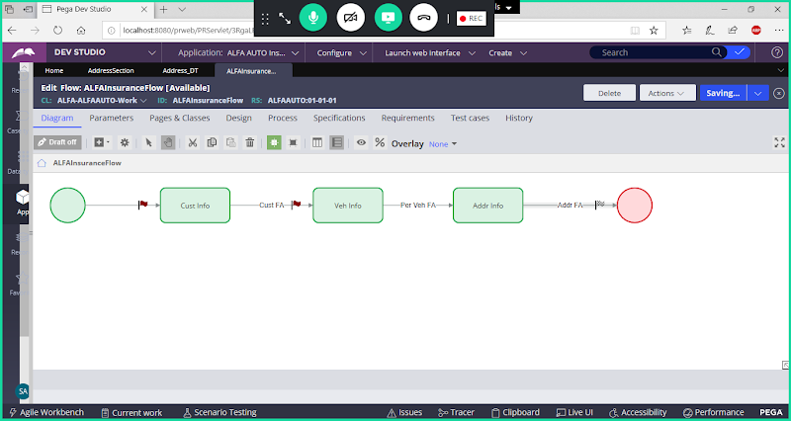

**Save Flow**

**Run Flow & Test**

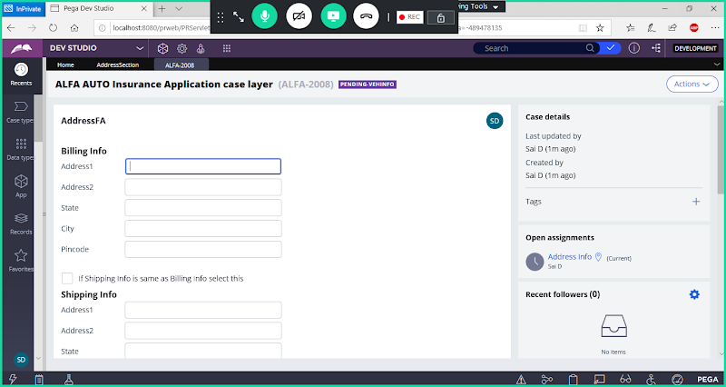

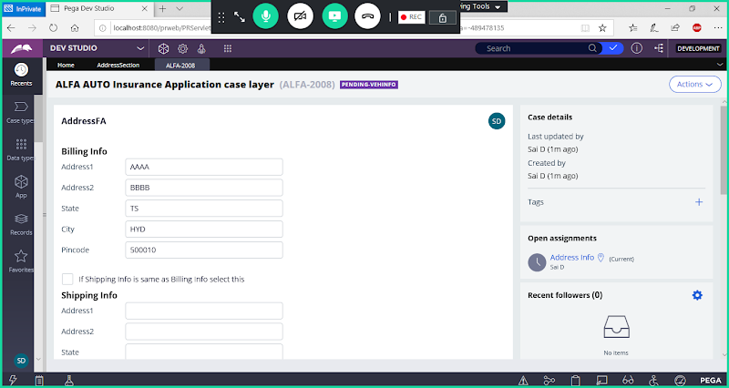

**Select Check Box:**

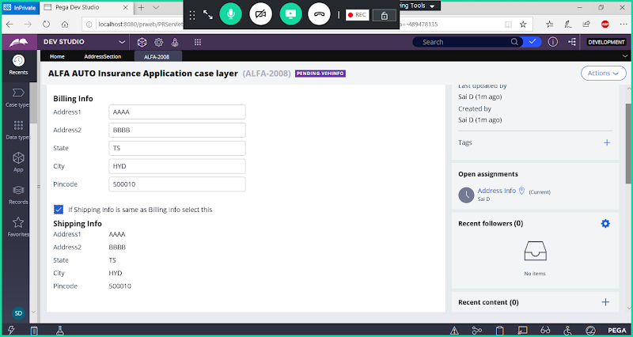

**If Check box Not selected they can provide new values in Shipping Address Page**

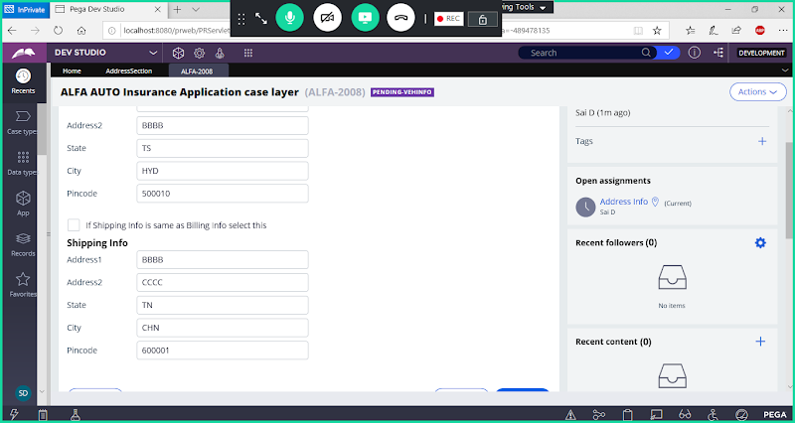

**========**

**More Info about data Transform: pyDefault**

**When executing Flow: default Prefix: C-**

**Work Object ID Prefix can be set in 2 ways:**

**1- From pyDeafult DataTransform we can see the Default Work Object ID Prefix  ( C-)**

**2- Application Definition -> Cases & Data   ( ALFA-/A-)**

**First it Will Check in pyDefault Data Transform & Last it will check in Cases & Data**

**Remove ALFA- /A- from Work ID Prefix**

**Open Application Definition:**

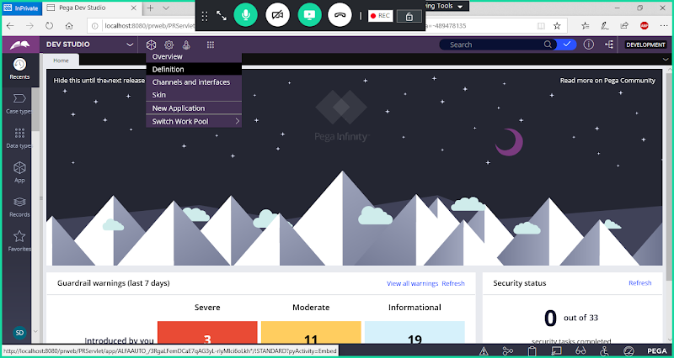

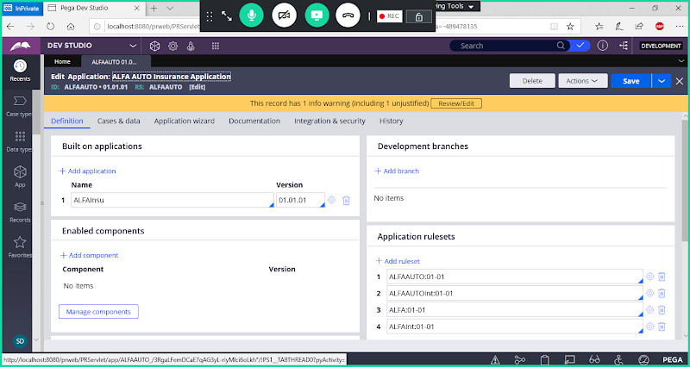

**Go to Cases & Data Tab:**

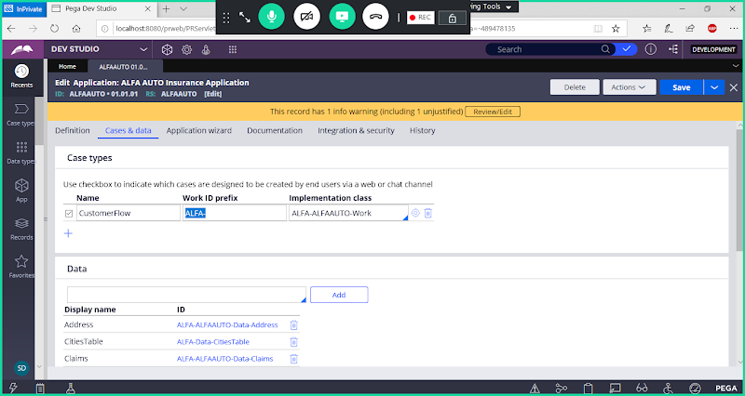

**Remove Work ID Prefix**

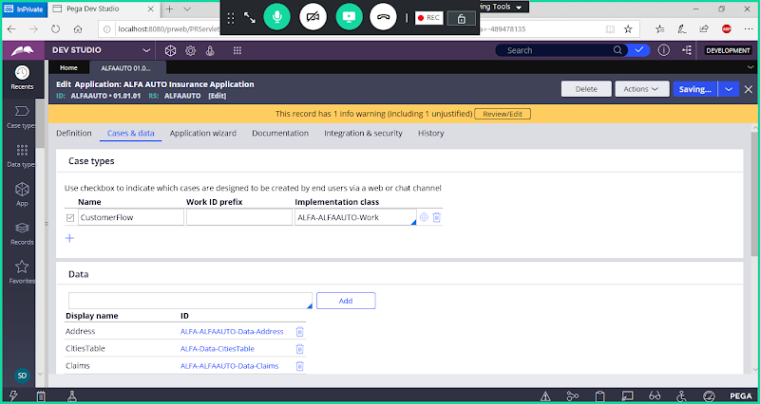

**Save Application definition**

**====**

**How to Open pyDefault data transform:**

**Open any Flow -> go to Process Tab of Flow**

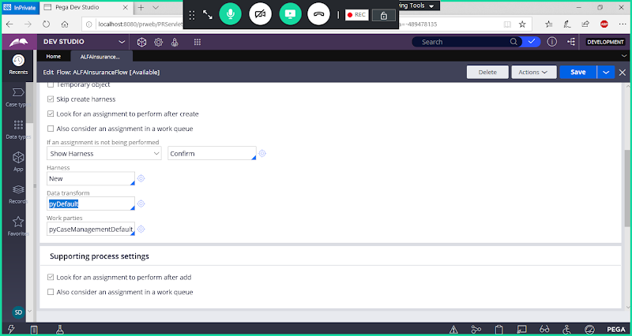

**Open pyDefault from the Circle**

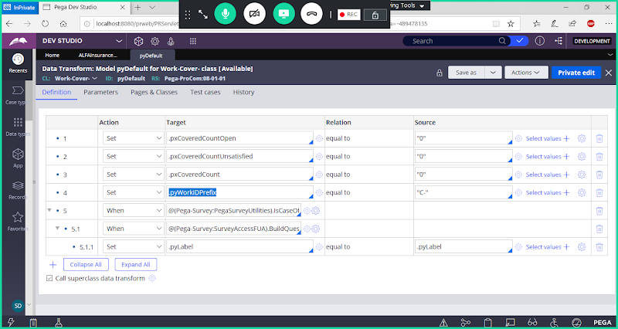

**Work Object ID Prefix is Assigned a Predefined Property: pyWorkIDPrefix**

**How to Update Default Prefix from pyDeafult Data Transform: Update Work Object ID prefix to Data Format.**

**Use saveas Option**

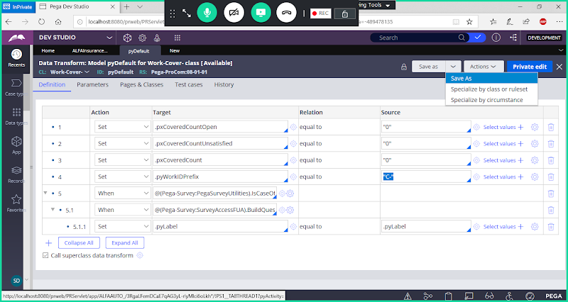

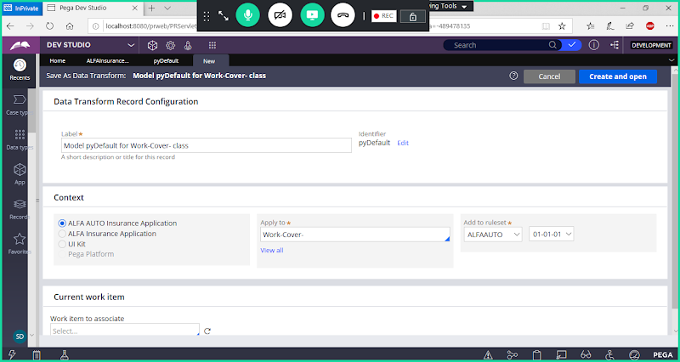

**No Need to Update Label & Class Name**

**Open The Rule**

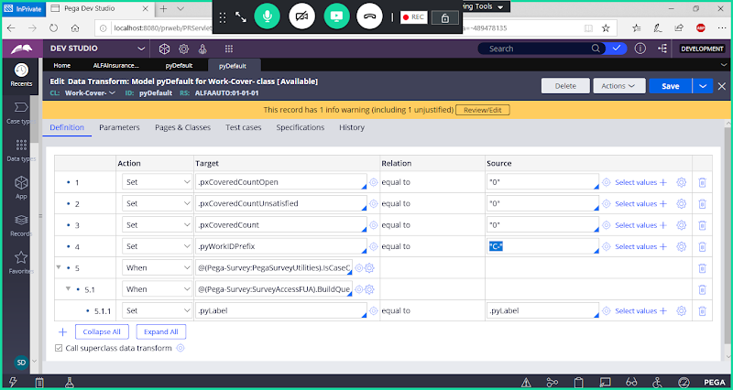

**Update Default Prefix C- with Current Date Stamp:**

**From pyWorkIDPrefix Step Open Expression Builder:**

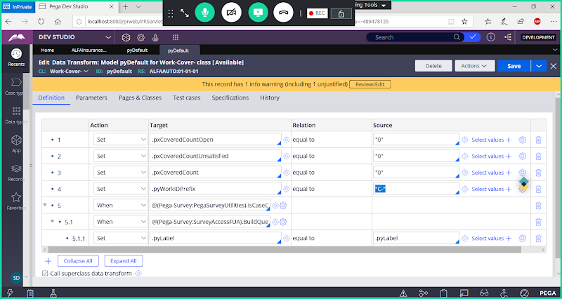

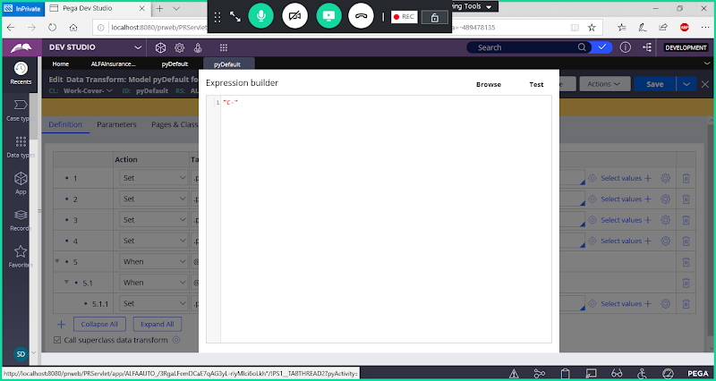

**Click on Browse tab:**

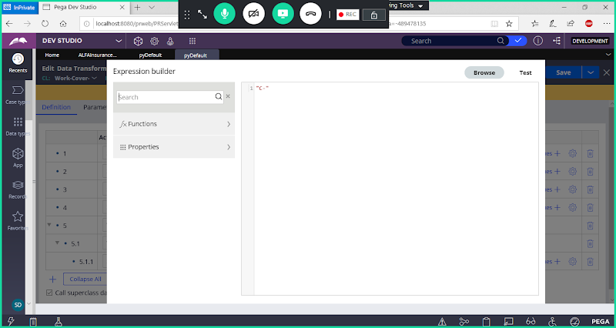

**Add Function: getCurrentDateStamp**

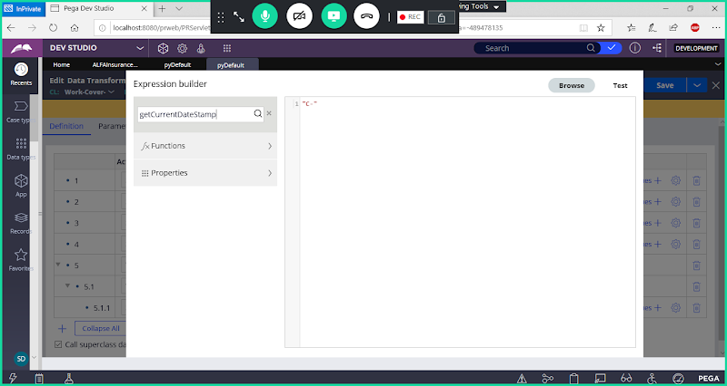

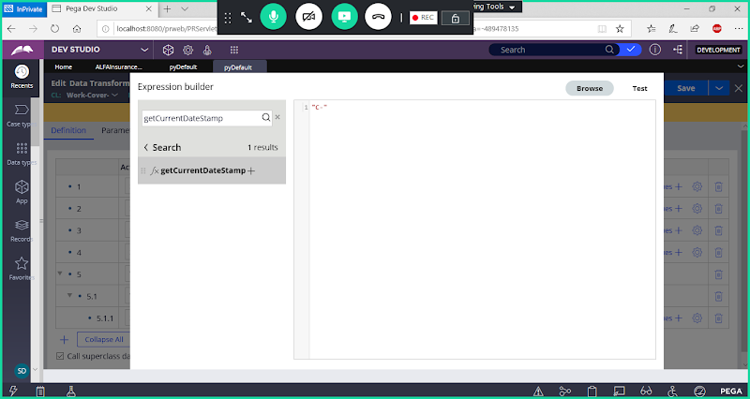

**Click on Add**

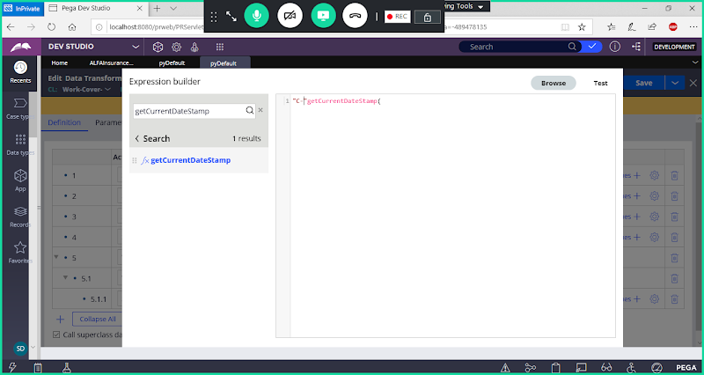

**Now Update According to requirement**

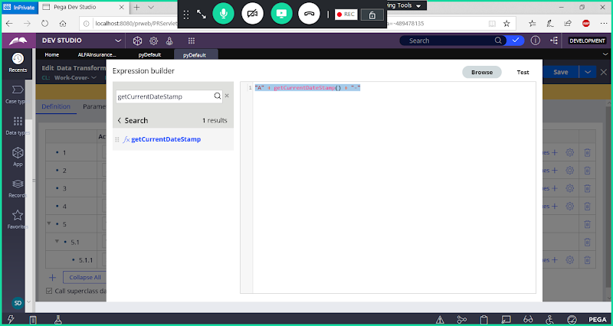

**"A" + getCurrentDateStamp() + "-"**

**Click on Test**

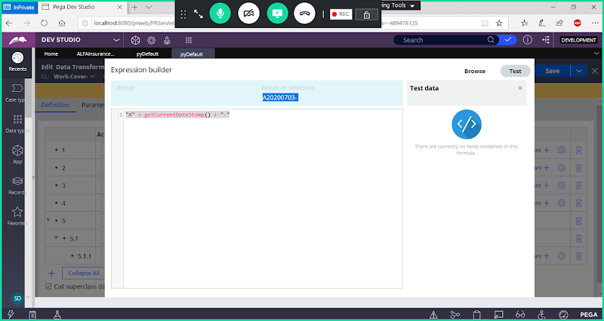

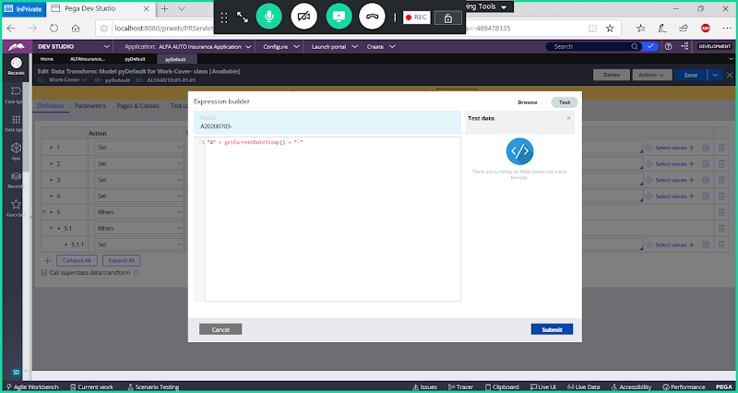

**Click on Submit**

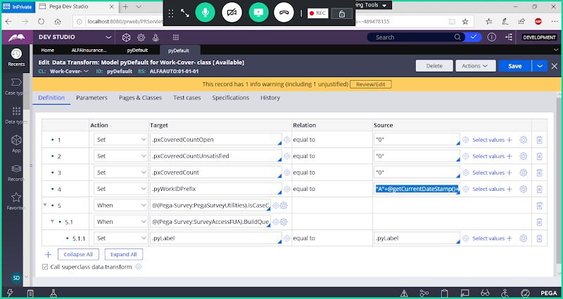

**Save Data Transform**

**Refresh browser & Run any Flow**

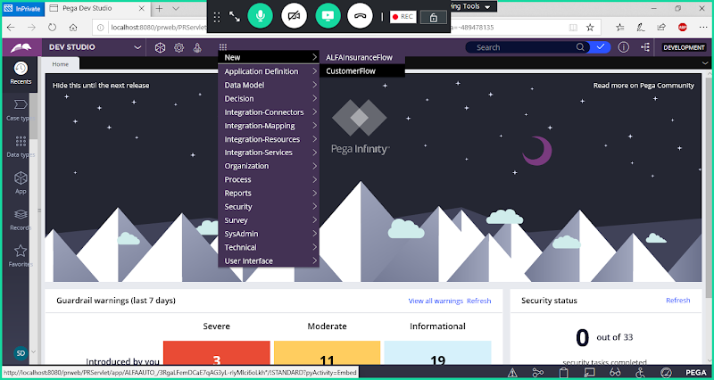

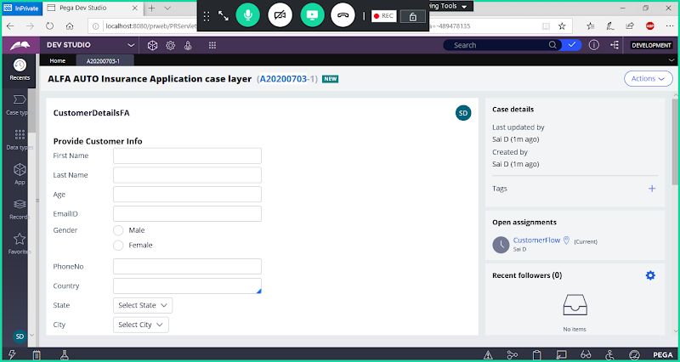

**================**

**Declarative Rules:**

**Declarative Rule are defined under Decision Category**

**Advantage: No need to call rule anywhere**

**Disadvantage: We cannot restrict the rule from Calling**

**Declarative Rules gets executed automatically without calling. Whenever properties are used/Updated & any data table value changes**

**Types of Declarative Rules:**

**Declare Expressions: We can perform calculations on properties**

**Declare Constraints: Restrict a Property to have specific value( Dependency Validations)**

**Declare Onchange: Based on Change in Property Value it will automatically calls Onchange Activity**

**Declare Trigger:  Based on any Table Value Changes it will automatically calls Trigger Activity**

**Declare Index: Used to fetch Page List property Values from the Index Table**